**WEEK 5 DEPLOYMENT OF MODEL AND API TO THE CLOUD**

* A free account was created on AWS and a simple Windows AMI ( Amazon Machine Image) was chosen for deployment.

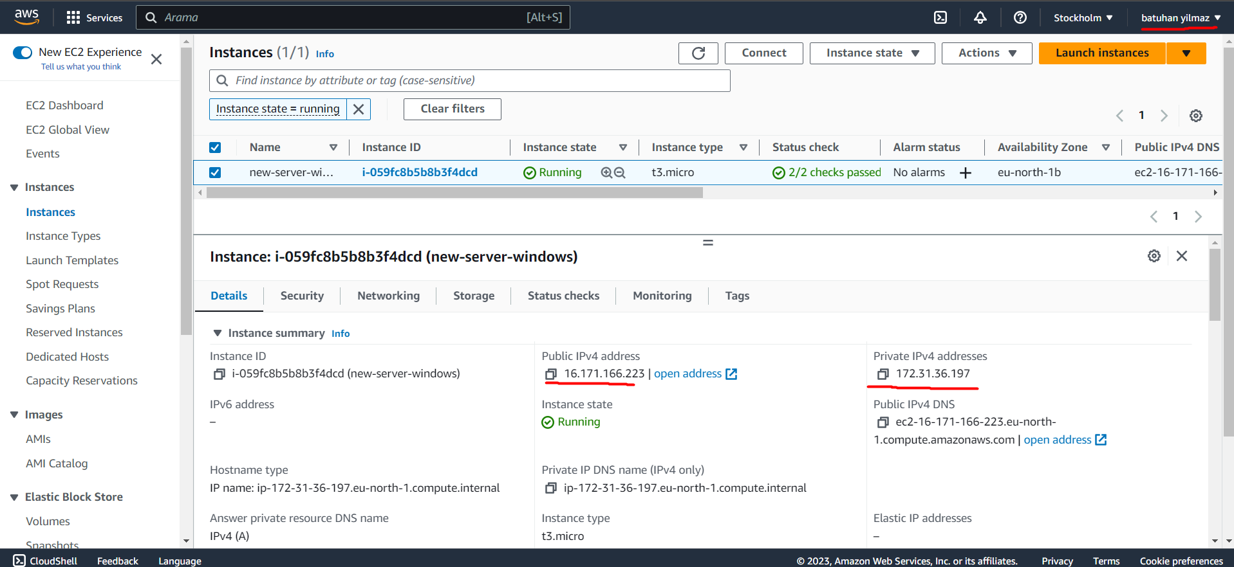

* Then, RDP ( Remote Desktop File) Tool was downloaded for remote Access to the virtual machine ( EC2 Instance).

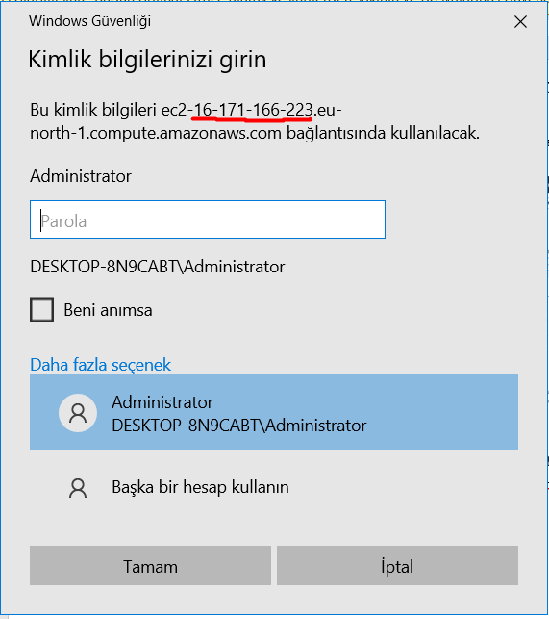

* After successfull Access to the remote computer, 2 different folders “flask-app” and “API” was created to keep the , respectively, web app and the api.

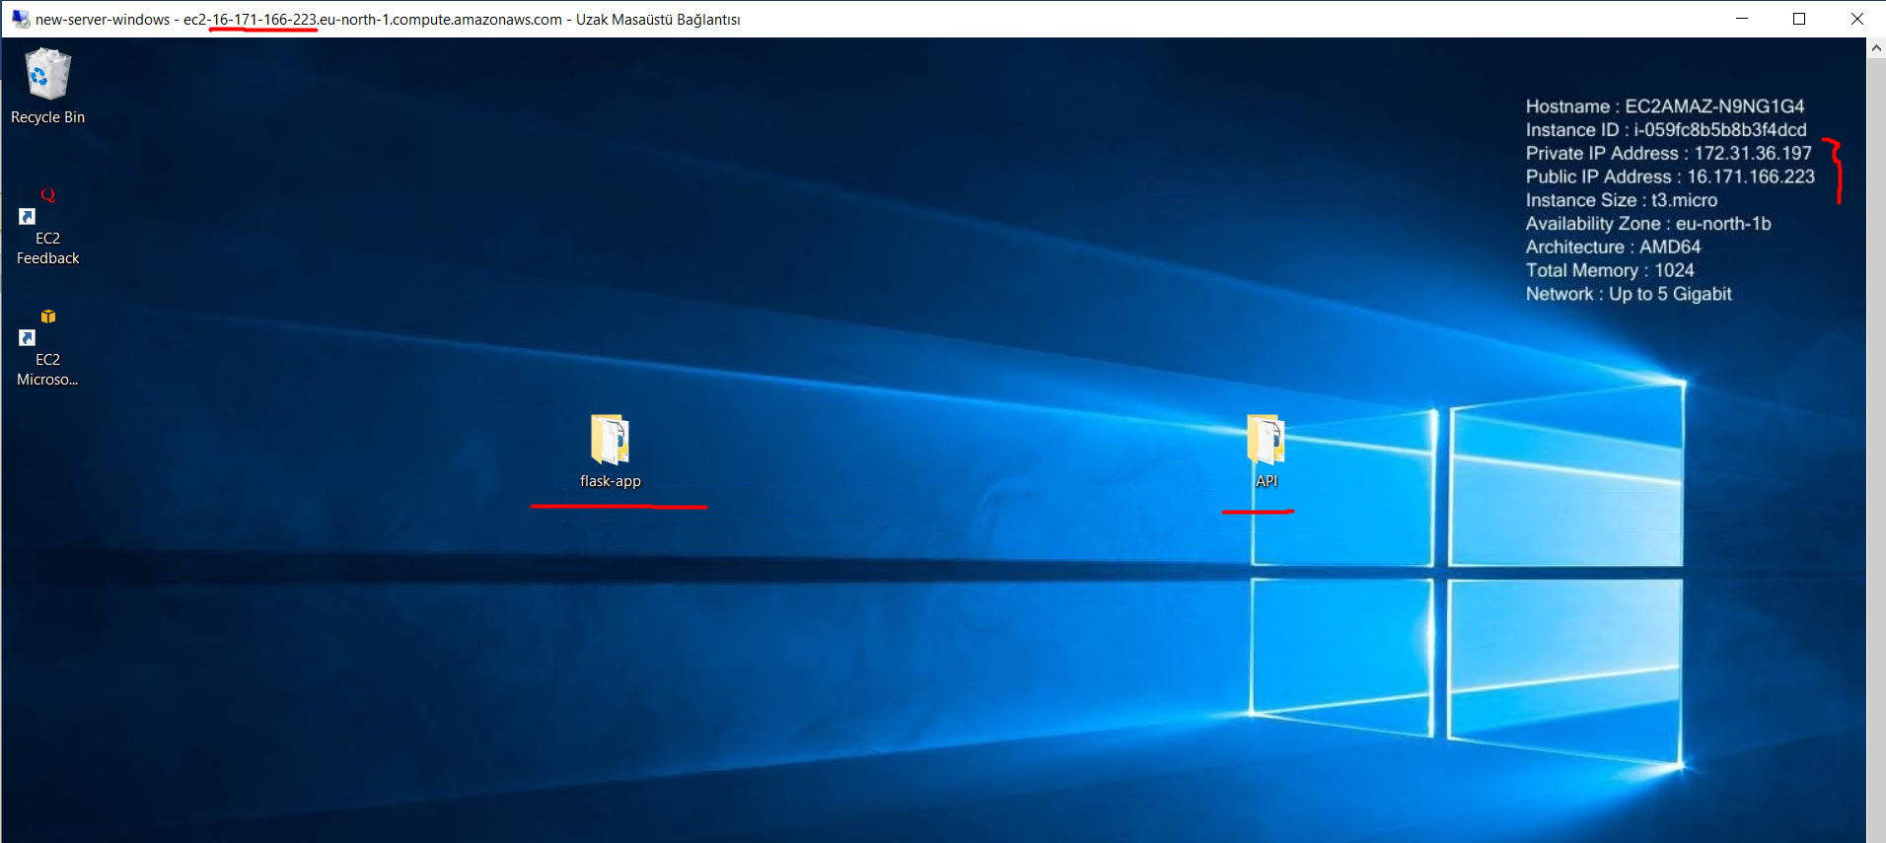

* After the creation of virtual environments, model prediction command and the model itself ( model.pkl file) was seperated from this file and moved to the API file. Following changes for remote Access to the server was done ( providing default way for host url and setting up the public IP for prediction of POST.)

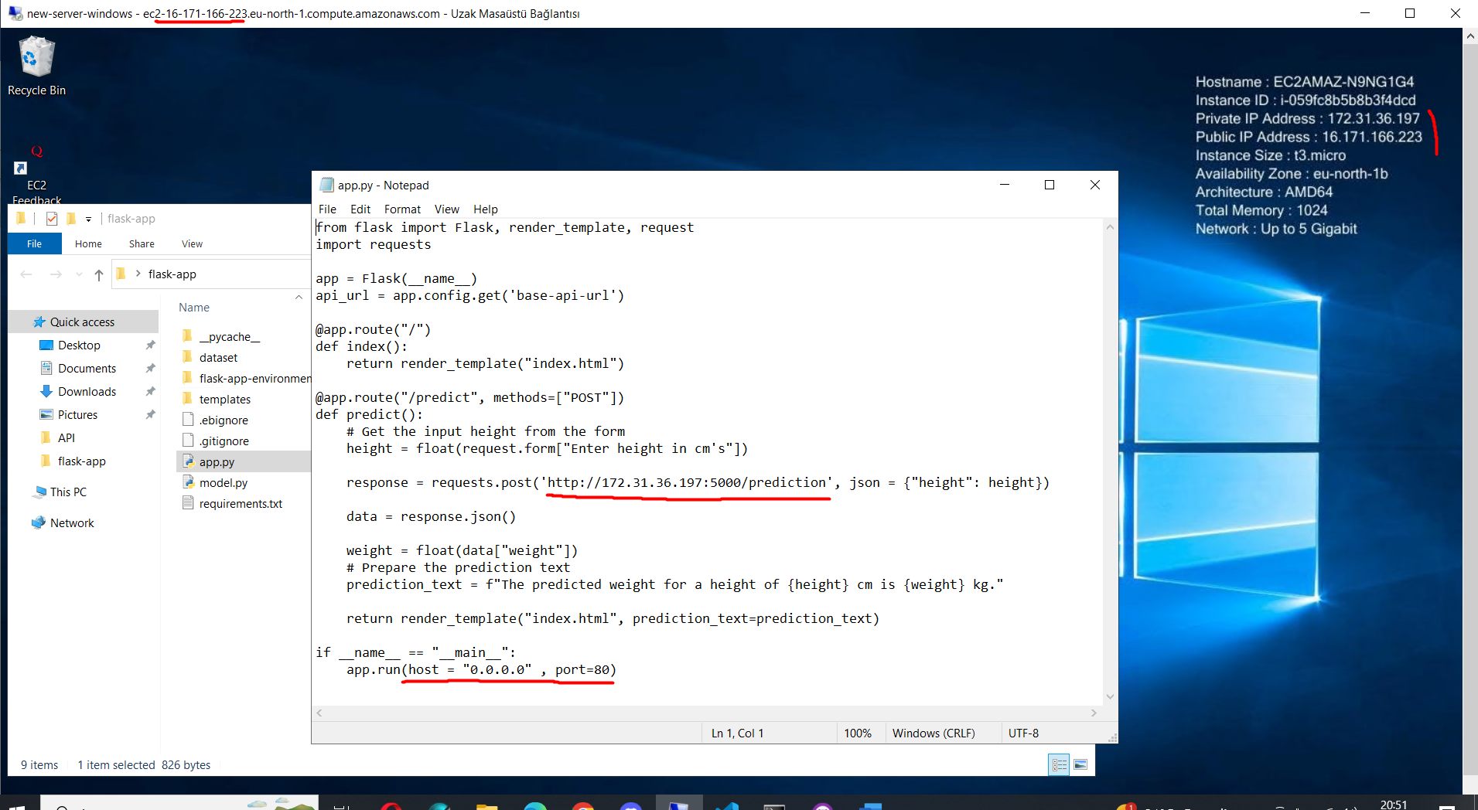

* In the API file, only the model and the code for making the prediction was held by setting up the API after downloading the Resource, API, flask_restful libraries:

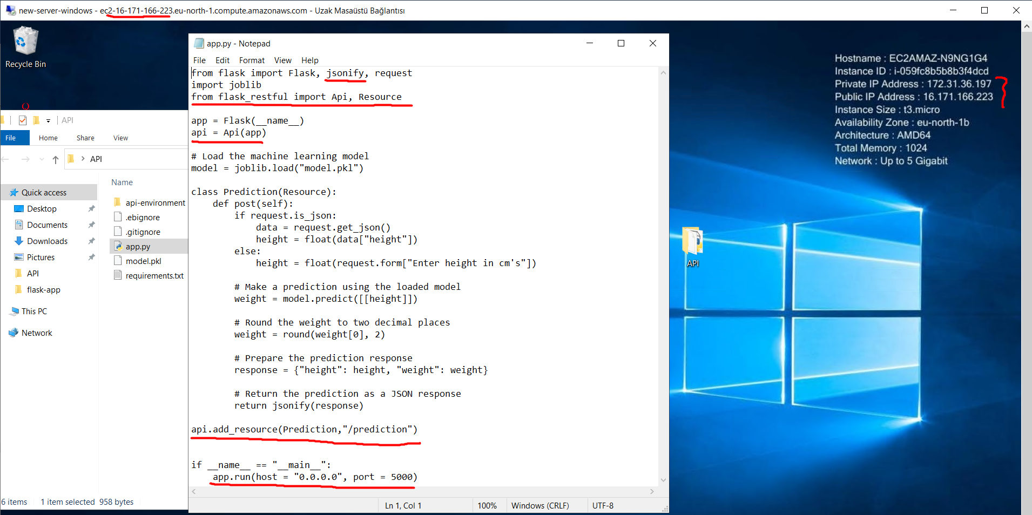

* Then, public IP Access was enabled from Windows firewall setting for third party users to be able to connect to it. Then, API and Flask App was run seperately as follow:

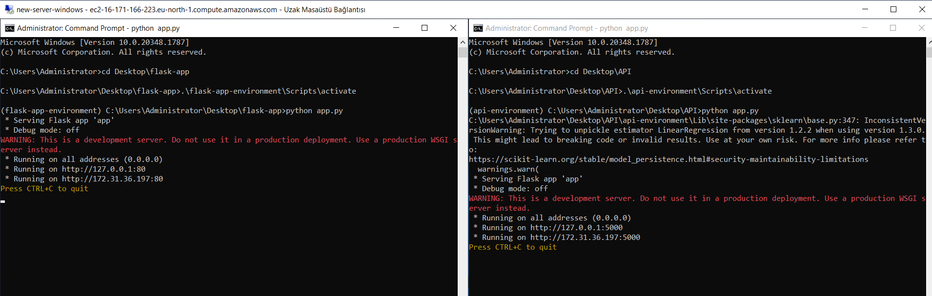

* Now, with a different computer, we are able to connect to public IP and Access the flask app and also the api ıtself for making predictions as follow:

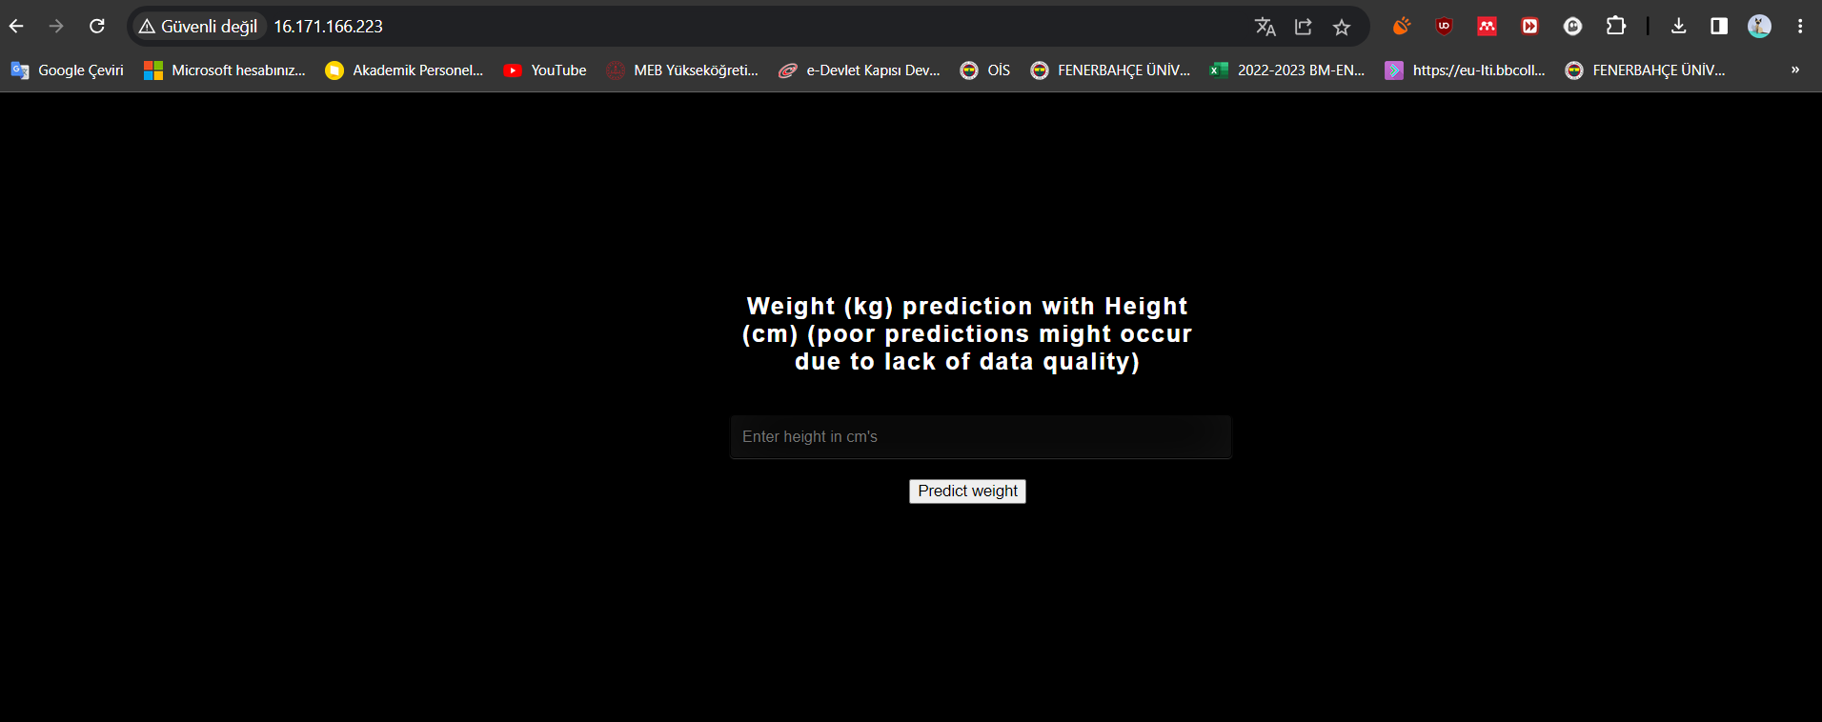

* With predictions from remote server:

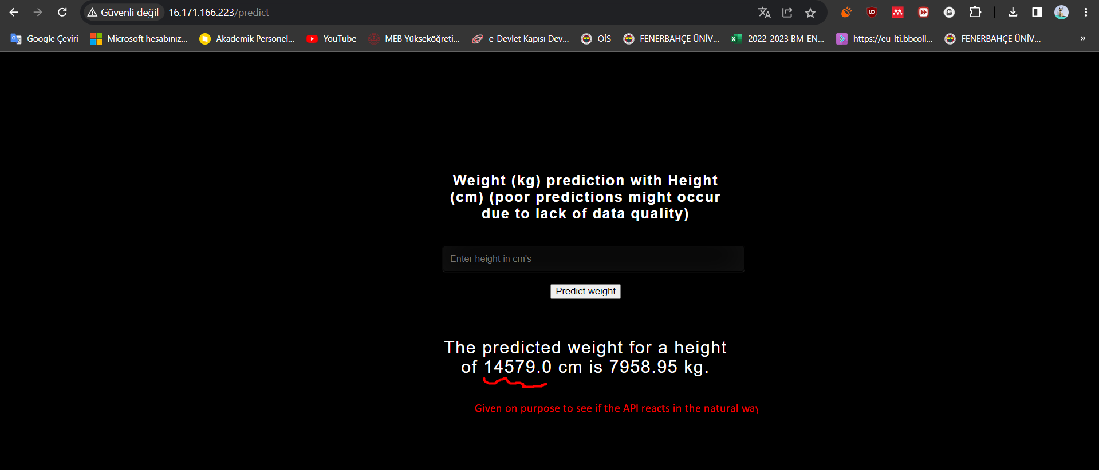

* Logs after a remote usage of the app.

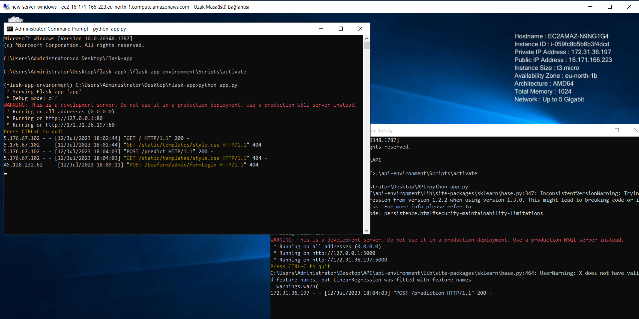

**Name** : Batuhan YILMAZ

**Batch Code** : LISUM22

**Submission Date** : 12.07.2023

**Submitted to :** Github

DataGlacier Remote Internship on Data Science